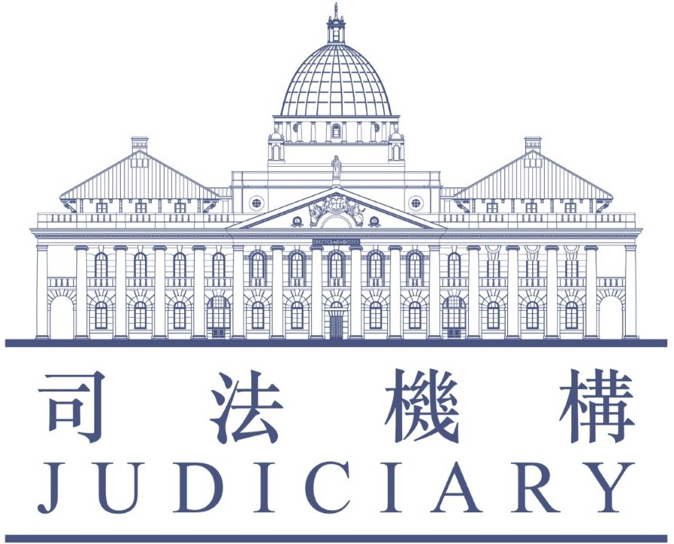

**Entry Form**

**List of Accredited Mediators** **for the   
Building Management Mediation Co-ordinator's Office**

PART I - PERSONAL PARTICULARS

1.1 Name (English): (Surname) Wo Mr.[1]*

(Other names) Wai Kwai Harmony (in full)

(Chinese): 和為貴

1.2 Hong Kong Identity Card*: X112008(2)

1.3 Profession (*Please choose only one box*)  Architect

 Barrister-at-law

 Counsellor

 Engineer

 Property Management Officer

 Psychologist

 Social Worker

 Solicitor

 Surveyor

 Therapist

 Others (*please specify*: )

1.4 Name of Employer (if any) (English): XYZ Surveyors Limited

(Chinese): 酉戌亥測量師行

1.5 Position in Organization (English): Senoir Building Surveyor

(Chinese): 高級屋宇測量師

1.6 Correspondence Address (English): Room 206, 38 Gascoigne Road, Kowloon

(Chinese): 九龍加士居道38號206室

1.7 Telephone No.: (Office) 2170 3858 (Mobile)

1.8 Fax No.: 2782 5780

1.9 Email Address: harmony@xyz.com

1.10 Academic Qualification (Institutes and year obtained):

Bachelor of Science in Surveying (University of Society, 1997)

PART II – RELEVANT EXPERIENCE AND INFORMATION

2.1 Details of Accreditation in the Hong Kong Mediation Accreditation Association Limited (“HKMAAL”):

*(please attach certificate from HKMAAL and note item 4.4)*

(i) Date obtained (Month/Year): 1 / 2015 .

(ii) Practising mediation since (Month/Year): 10 / 2015 .

(iii) Approximate no. of mediation cases handled in the past 3 years

9 case(s)

2.2 Relevant Experience in the Fields of Law or Mediation:  
*(If there is insufficient space, please give details on a separate sheet to be attached to the Entry Form.)*

|  |  |  |
| --- | --- | --- |
| Date | Name of Organization | Type of Work |
| 2015 to present | Hong Kong Mediation Organization | Mediation service |

2.3 Mediation Service Offered and Venue for Mediation:

(i) Fees Charging:

(*You may choose more than one box*)

 Pro bono service for 10 case(s), subject to a maximum of 15 hours per case.

*(Mediators may consider extending the number of hour if it would facilitate an agreement between parties concerned, as and when appropriate)*

 Fee-charging service at an hourly rate of HK$ x,xxx .

 Others (Please specify)

1. Venue for Mediation Appointments:

(*Please choose only one box*)

 I will provide mediation venue as follow:

Chinese: 香港和平道18號3樓

English: 3rd Floor, 18 Peace Road, Hong Kong

*Office hours:*  Weekdays

 Office Hours

 Non Office Hours

 Saturday

 Sunday

 Public Holidays

(*You may choose more than one box*)

(*N.B.: Office hours denote normal working hours*

*(i.e. 9am. - 6pm.)*)

 I will not provide mediation venue

# Available to provide Online Mediation:

# *(Please choose only one box)*

 Yes

 No

2.4 Language and Dialect Proficiency:

1. I have the skills and expertise in the following language/dialect:

(*You may choose more than one box*)

 English  Cantonese  Putonghua

 Others (Please specify)

1. I have the skills and expertise in drafting documents in:

(*You may choose more than one box*)

 English  Chinese

 Others (Please specify)

PART III – PROFILE SUMMARY

|  |  |  |
| --- | --- | --- |
| Name (Mr.[2]*)  姓名 (先生*) | | Mr. Wo Wai Kwai Harmony  和為貴先生 |
| Profession  專業 | | Surveyor  測量師 |
| Name of Accreditation Body 調解員資格認可機構 | | Hong Kong Mediation Accreditation Association Limited  香港調解資歷評審協會 |
| Year of Accreditation  取得調解員資格年份 | | Year 2015  2015年 |
| Practising Mediation since 從事調解工作自 | | Year 2015  2015年 |
| No. of Mediation Cases Handled In The Past 3 Years  過去三年處理調解個案數目 | | 9 cases(s)  9 宗 |
| Language /  Dialect Proficiency  語言能力 | Spoken 交談 | English, Cantonese, Putonghua  英語, 粵語, 普通話 |
| Written書寫 | English, Chinese  英文, 中文 |
| Pro Bono /  Mediation Fee To Be Charged 免費 / 調解費用 | | Pro bono / $x,xxx per hour  免費 / 每小時$x,xxx |
| Venue for Mediation Appointment  調解會面地址 | | 3rd Floor, 18 Peace Road, Hong Kong  香港和平道 18號 3樓 |
| Time for Mediation Appointment  調解會面時間 | | Weekdays (Office hours), Saturdays  星期一至星期五 (辦公時間)、星期六 |
| Telephone No.  電話 | | (Office): 2170 3858  (Mobile): |
| Fax. No.  傳真 | | 2782 5780 |

PART IV - DECLARATION

4.1 I declare that the information provided in this Entry Form is accurate to the best of my knowledge and belief.

4.2 I understand that the information provided on this Entry Form namely, the mediator’s name, profession, name of accreditation body, year of accreditation, the year commencing practising mediation, no. of mediation cases handled in the past 3 years, language/dialect proficiency (spoken and written), pro bono/mediation fee to be charged, venue and time for mediation appointment, telephone and fax number may be included in the **List of Accredited Mediators** at the discretion of the Building Management Mediation Co-ordinator’s Office (“BMMCO”) and may be accessible to members of the public upon enquiry.

4.3 I agree to notify the Mediation Co-ordinator as soon as possible:

1. if there is any change in the information provided in this Entry Form; and
2. if I am not available to take on any mediation work for a period of 4 weeks or more.

4.4 I undertake to notify the Mediation Co-ordinator if I cease to be Accredited Mediator/member of HKMAAL.

4.5 I undertake to abide by the following terms if I receive cases which have attended Information Sessions and/or Pre-mediation Consultation at BMMCO:

1. to comply with the mediation Rules and relevant Guidelines of HKMAAL and the Hong Kong Mediation Code; and
2. to provide mediation case statistics and data as required by BMMCO for the purposes of evaluation of mediation service of the Office.

4.6 I apply to have my name included on the List of Accredited Mediators. I also agree to the access of the Mediation Co-ordinator to my personal data kept in HKMAAL.

Date: 14 March 2022 Signature:

*Note*:

1. Please submit the Entry Form (Part I, II & III in MS Word format), with scanned Part IV and Certificate of Accreditation Body to Building Management Mediation Co-ordinator’s Office by email at [bmmco@judiciary.hk](mailto:bmmco@judiciary.hk). Alternatively, you may submit the completed Entry Form with a copy of Certificate of HKMAAL by fax or by post:

Address: Room 206 - 208, 2/F,  
Lands Tribunal Building,  
38 Gascoigne Road,  
Kowloon

Fax: 2782 5780

1. Applicants are advised to provide all the information requested in the relevant documents, where applicable, failing which the Mediation Co-ordinator may refuse to process and consider their applications.
2. The Mediation Co-ordinator reserves the right to require further information or proof as to the information provided.
3. For enquiries concerning submission of this Entry Form, please contact Mediation Co-ordinator at 2170 3858.

PART V – STATEMENT OF COLLECTION

Purpose of Collection

5.1 The personal data provided in this form will be used:-

1. for arranging mediation service; and
2. for the purposes of enabling the Mediation Co-ordinator to discharge her duties and functions under the Building Management Mediation Co-ordinator’s Office and may be accessible to members of the public upon enquiry.

5.2 The provision of personal data by you is voluntary. If you do not provide sufficient information, the Mediation Co-ordinator may not be able to process your application for your name to be included on the List of Accredited Mediators.

Classes of Transferees

5.3 The personal data you provide on this form may be disclosed to the public, government departments or other relevant parties for the purposes stated in paragraph 5.1 above.

Access and Correction of Personal Data

5.4 You have a right of access and correction with respect to your personal data as provided for in Sections 18 and 22 and Principle 6 of Schedule 1 of the Personal Data (Privacy) Ordinance (Cap. 486). Your right of access includes the right to obtain a copy of your personal data provided by this form upon payment of a prescribed fee.

Enquiries

5.5 Enquiries concerning the personal data collected by means of this form, including the making of request for access and correction, should be addressed to:

Mediation Co-ordinator

Building Management Mediation Co-ordinator’s Office

Room 206 - 208, 2/F,

Lands Tribunal Building,  
38 Gascoigne Road,

Kowloon

Tel.: 2170 3858

1. * Please delete as appropriate
2. * Please delete as appropriate